Lab # 05

The while loop

Objective
In this lab, we learned how to use loops in C++. The main focus was on:
- The while loop
- The nested while loop
- The do...while loop

Introduction
Loops are used in C++ to repeat a task multiple times. They help reduce code and make programs easier to write.

Types of Loops Studied

1. While Loop
- It checks the condition first.
- If the condition is true, the loop runs.
- If false, it stops.

2. Nested While Loop
- A while loop inside another while loop.
- Used when we need repetition inside another repetition.

3. Do...While Loop
- It runs the code at least one time.
- Then it checks the condition.

Conclusion
In this lab, we learned how different loops work in C++. We now understand how to repeat tasks using while, nested while, and do...while loops.
Lab 05 tasks
1: while Loop
• Write a C++ program that uses a while loop to display numbers from 1 to 10.
• Display each number on a separate line
Code:
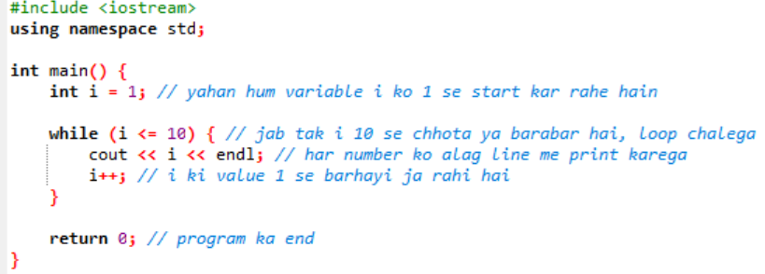

2. Repeat the first task using do... while loop
Code:
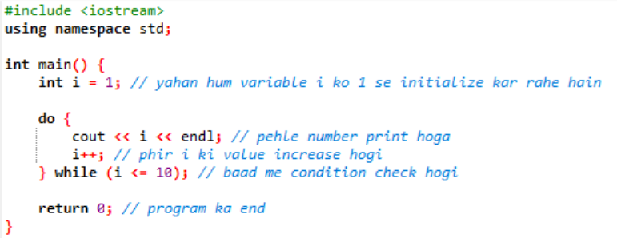
3. Sum using while Loop
• Write a C++ program that prompts the user to enter a positive integer.
• Use a while loop to calculate the sum of all numbers from 1 to the entered integer.
• Display the calculated sum
Code:
